**IS 610 GROUP PROJECT 1**

**ACHIEVERS CONSULTANCY (*For Better Career*)**

**UMBC-SPRING 2023**

**Team Members:**

Jagadeeswari Sambangi

Amruthavarshini Sadineni

Vineeth Petnakota

Devanshi Patel

**DETAILED ERD**

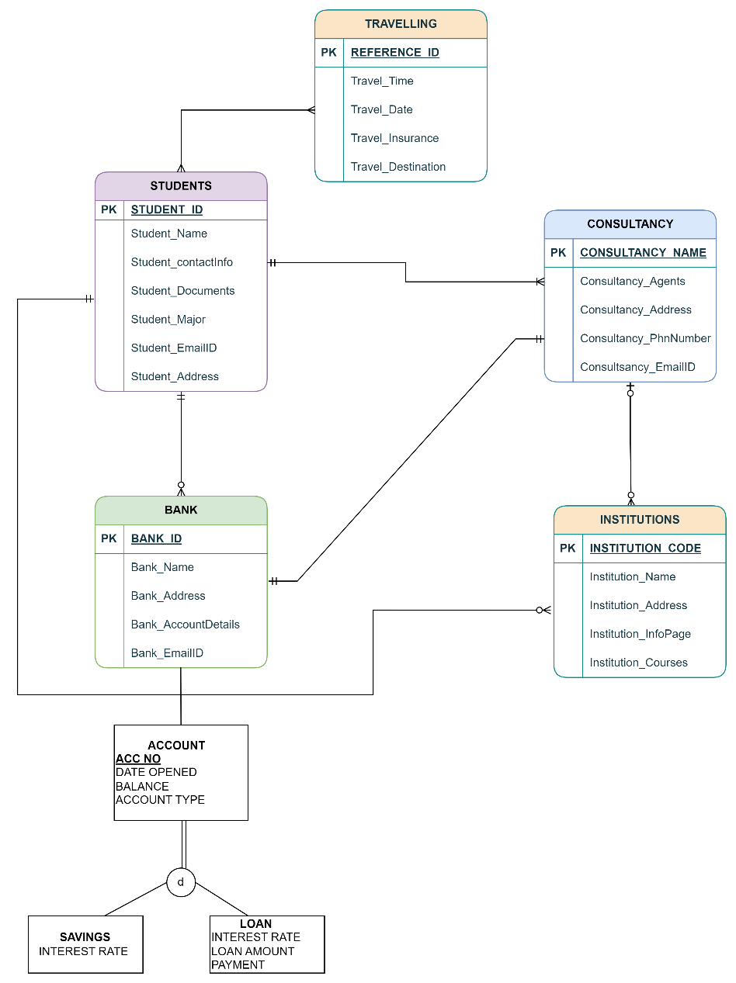

**ENTITIES**

|  |  |  |  |  |  |
| --- | --- | --- | --- | --- | --- |
| **ENTITIES** | **STRONG ENTITY** | **WEAK ENTITY** | **ASSOCIATIVE**  **ENTITY** | **SUBTYPE** | **SUPER TYPE** |
| **STUDENT** | **X** |  |  |  |  |
| **INSTITUTION** | **X** |  |  | **X** |  |
| **CONSULTANCY** |  | **X** | **X** |  | **X** |
| **BANK** |  |  |  | **X** |  |
| **TRAVEL** |  |  |  | **X** |  |

STRONG ENTITY

* Students
* Institution
* Bank

WEAK ENTITY:

* Consultancy
* Travel

ASSOCIATIVE ENTITY:

* Consultancy

SUPERTYPE:

* Bank

SUBTYPE:

* Savings Account for Super type Bank.
* Loan Account for Super type Bank.

**RELATIONSHIPS**

* Students can travel many times.
* There can be many Travels associate with each student.
* Student can approach one or many consultancies.
* Consultancy will have more than one student.
* Student can have no or multiple bank loans.
* Each bank loan will be associated with single student.
* Student must have applied to many institutions whereas institutions will have fixed number of students.
* Consultancy may have tie-up with many institutions whereas institutions may or may not have consultancy agent.
* Students who take loan will have different type of accounts such as “Savings type” and “Loan type”

**NOTE**: Savings and Loan are sub-type Entities of Super Entity “Bank”.

|  |  |
| --- | --- |
| **STUDENT** | **DEFINITION OF RELATIONSHIP** |
| STUDENT_ID  STUDENT_NAME  STUDENT_EMAILID  STUDENT_CONTACTINFO  STUDENT_ADDRESS  STUDENT_DOCUMENTS  STUDENT_MAJOR | KEY IDENTIFIER  SIMPLE  MULTI-VAULED  MULTI-VALUED  COMPOSITE  COMPOSITE  SIMPLE |

|  |  |
| --- | --- |
| **INSTITUTION** | **DEFINITION OF RELATIONSHIP** |
| INSTITUTION_NAME  INSTITUTION_ADDRESS  INSTITUTION_INFOPAGE | KEY IDENTIFIER  COMPOSITE  COMPOSITE |

|  |  |
| --- | --- |
| **CONSULTANCY** | **DEFINITION OF RELATIONSHIP** |
| CONSULTANCY_NAME  CONSULTANCY_AGENTS  CONSULTANCY_ADDRESS  CONSULTANCY_PHONENUMBER  CONSULTANCY_EMAILID | KEY IDENTIFIER  ASSOCIATIVE  COMPOSITE  MULTI-VAULED  MULTI-VAULED |

|  |  |
| --- | --- |
| **BANK** | **DEFINITION OF RELATIONSHIP** |
| BANK_ID  BANK_NAME  BANK_ADDRESS  BANK_EMAILID  BANK_ACCOUNTDETAILS | KEY IDENTIFIER  SIMPLE  COMPOSITE  MULTI-VAULED  COMPOSITE |

|  |  |
| --- | --- |
| **TRAVEL** | **DEFINITION OF RELATIONSHIP** |
| REFERENCE_ID  TRAVEL_TIME  TRAVEL_DATE  TRAVEL_INSURANCE  TRAVEL_DESTINATION | KEY IDENTIFIER  SIMPLE  SIMPLE  MULTI-VAULED  SINGLE-VAULED |